**Assignment No: - 2**

**Facial Recognition using OpenCV**

**Problem Statement:**

Facial Recognition Using OpenCV and Deep Learning for Binary Classification.

**Objective:**

* Understand the fundamentals of face detection and recognition.
* Learn to preprocess face data and extract facial embeddings.
* Implement a deep learning-based model to classify faces.
* Evaluate the model's accuracy and performance.
* Visualize the training process and performance metrics.

**S/W Packages and H/W apparatus used:** Operating System: Windows/Linux/MacOS, Kernel: Python 3.x, Tools: Jupyter Notebook, Anaconda, or Google Colab, Hardware: CPU with minimum 4GB RAM; optional GPU for faster training

**Libraries and packages used:** OpenCV, TensorFlow/Keras, Dlib, face_recognition, NumPy, Pandas, Matplotlib, Scikit-Learn

**Theory:**

**Definition:** A facial recognition system is a technology capable of identifying or verifying a person from a digital image or video frame. The system works by detecting facial features and matching them against a pre-stored database. In binary classification, the task is to distinguish between two classes, typically "face" and "no face."

**Structure:** It consists of:

* **Face Detection Module:** Detects the presence of a face in the input image using techniques like Haar Cascades or deep learning models (SSD or YOLO).
* **Feature Extraction Module:** Extracts unique facial features from the detected region using Convolutional Neural Networks (CNNs).
* **Classification Module:** Binary classifier (CNN or SVM) that outputs whether the detected region contains a face or not.

**Activation Functions:** Functions like ReLU (Rectified Linear Unit), Sigmoid, and SoftMax are used to introduce non-linearity into the classification model, enabling it to learn complex patterns.

**Backpropagation:** A critical algorithm for training the CNN-based model, where the error between predicted and true labels is propagated backward to update the weights in each layer to minimize classification error.

**OpenCV:**

OpenCV (Open Source Computer Vision Library) is an open-source computer vision and machine learning software library. Originally developed by Intel, it supports various programming languages like C++, Python, Java, and MATLAB, making it versatile for computer vision projects. Here's an overview of what OpenCV offers:

* Image Processing: OpenCV provides functions for various image processing tasks such as filtering, edge detection, color space conversion, and geometric transformations.
* Object Detection: With algorithms like Haar cascades, YOLO, and SSD, OpenCV helps detect and track objects in images and videos.
* Face Detection and Recognition: It includes pre-trained models for detecting faces and recognizing facial features, which can be fine-tuned for more specific applications.
* Video Analysis: Features for processing video frames in real time, including background subtraction, motion detection, and optical flow analysis.
* Machine Learning Integration: OpenCV has built-in modules for machine learning, supporting algorithms such as k-nearest neighbors (KNN), support vector machines (SVM), and deep learning frameworks (TensorFlow, Caffe, PyTorch).

**Advantages:**

* **High Accuracy:** Deep learning provides high precision in recognizing and classifying faces.
* **Real-Time Processing:** OpenCV allows for real-time face detection and recognition.
* **Automation:** The system can automate tasks such as authentication and access control.

**Limitations:**

* **Data Quality and Quantity:** Facial recognition systems require a large, diverse, and high-quality dataset for training. Poor-quality images or insufficient training data can lead to inaccurate predictions and difficulty in generalizing to new faces.
* **Illumination and Pose Variability:** Variations in lighting, pose, facial expressions, and occlusions (like glasses or hats) can significantly affect the model's accuracy, leading to false positives or false negatives.
* **Privacy Concerns:** Facial recognition technology raises significant ethical and privacy issues. The unauthorized collection and use of facial data can infringe on personal privacy rights, leading to regulatory and legal challenges.
* **Computational Complexity:** Deep learning-based facial recognition models, especially with large-scale datasets, require significant computational resources for training and deployment, which may not be suitable for real-time or low-power devices.
* **Overfitting:** If the model is overly complex or trained on limited or biased data, it can overfit to the training data, resulting in poor performance on real-world or unseen images.
* **Adversarial Vulnerabilities:** Facial recognition systems can be susceptible to adversarial attacks, where small perturbations in the image can fool the system into misclassifying a face.

**Applications:**

* **Security and Surveillance:** Facial recognition is widely used in security systems for access control, identifying individuals in surveillance footage, and monitoring high-security areas.
* **Biometric Authentication:** Facial recognition is employed in smartphones, laptops, and other devices for user authentication, providing a convenient and secure alternative to passwords.
* **Law Enforcement:** Police and other law enforcement agencies use facial recognition to identify suspects in criminal investigations, locate missing persons, or track criminals across large datasets.
* **Healthcare:** Facial recognition can be used in healthcare to monitor patient conditions, detect emotional states, and assist in diagnosing genetic disorders based on facial features.
* **Retail and Marketing:** In retail environments, facial recognition is used for personalized marketing, customer identification, and enhancing customer experience by analyzing shopping patterns.
* **Time and Attendance Systems:** Many businesses employ facial recognition for tracking employee attendance and enhancing workplace security by automating time-in/time-out processes.
* **Smart Cities:** Facial recognition technology can be integrated into smart city infrastructure for traffic monitoring, crowd control, and improving public safety.

**Working / Algorithm:**

**Step 1 -** Import Necessary Libraries

* Import the required libraries: OpenCV (cv2) for computer vision tasks and Matplotlib (plt) for image visualization.

**Step 2** - Load the Image

* Use OpenCV's imread() function to load the image file. The image path should be correctly specified.
* The loaded image is in BGR color format (default format for OpenCV).

**Step 3 -** Convert BGR to RGB Format

* Convert the image from BGR format to RGB format using the cvtColor() function. This is necessary because Matplotlib uses the RGB format to display images correctly**.**

**Step 4 -** Load the Haar Cascade Classifier

* Load the pre-trained Haar Cascade classifier using the CascadeClassifier() function. This XML file contains the data needed to detect faces.
* The full path to the Haar Cascade file (haarcascade_frontalface_default.xml) should be provided.

**Step 5 -** Face Detection Using the Haar Cascade

* The detectMultiScale() method is used to detect faces in the image. This function returns a list of bounding boxes (coordinates) for all detected faces.
* The bounding boxes contain the x, y coordinates of the top-left corner, along with the width and height of each detected face.

**Step 6 -** Check if Any Faces Were Detected

* If the list of bounding boxes is empty, print "No faces detected."
* If faces are detected, proceed to the next steps.

**Step 7 -** Draw Rectangles Around Detected Faces

* Loop through the bounding boxes and extract the coordinates.
* Draw a rectangle around each detected face using rectangle() function from OpenCV. The rectangle is drawn over the original RGB image.

**Step 8 -** Display the Image with Detected Faces

* Use Matplotlib's imshow() function to display the image with rectangles drawn around the detected faces.
* Set the title of the plot as 'Face Detection' and hide the axes for a cleaner view.
* Finally, use plt.show() to render the image.

**Diagram:**

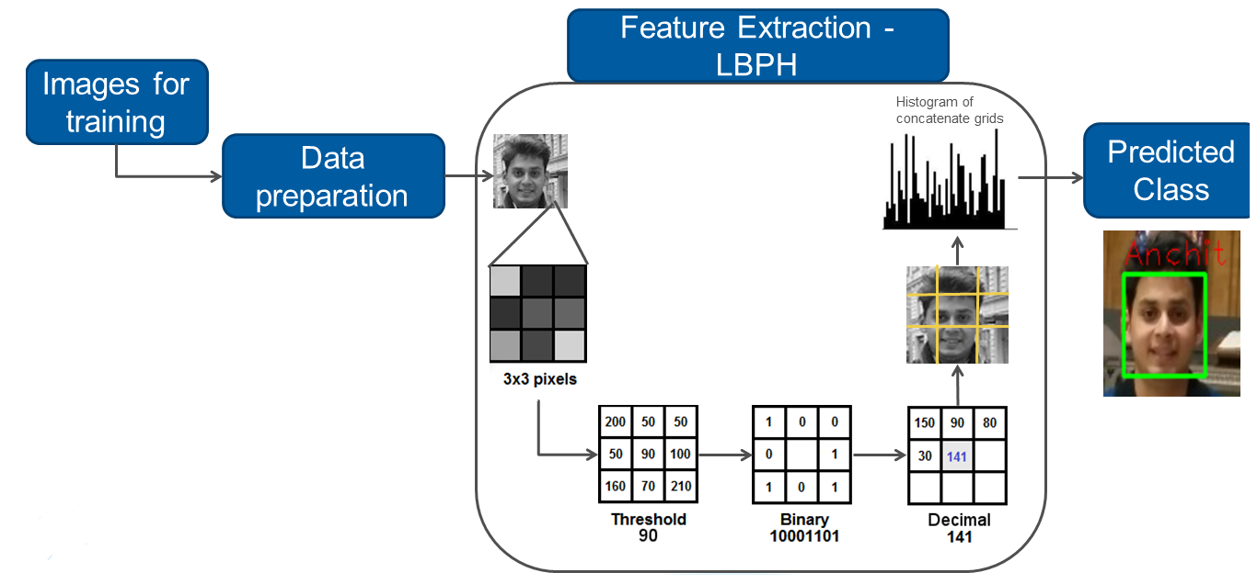

(Fig. 1 Flow of CNN multiclass classification)

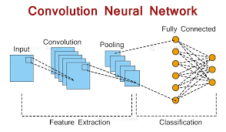

(Fig. 2 Architecture diagram of CNN)

**Conclusion:**

The Feedforward Neural Network (FNN) is an effective and flexible tool for facial recognition tasks, capable of learning complex patterns in image data. Its ability to handle non-linear relationships makes it suitable for distinguishing between different facial features. While FNNs offer strong predictive capabilities, challenges such as the need for substantial computational resources, risks of overfitting, and the necessity for meticulous hyperparameter tuning must be addressed. When effectively managed, FNNs can deliver robust performance in facial recognition applications, enhancing various technological solutions in security, user authentication, and more.